PRAKTIKUM BASIS DATA 11

MATA KULIAH:
BASIS DATA



Dosen Pengampu:
Ranny Meilisa, S.Kom.,M.Pd.T

Dibuat Oleh:
Teguh Tegar Aulia ( 20230801124 )

TEKNIK INFORMATIKA
UNIVERSITAS ESA UNGGUL
2024
STUDI KASUS
Kasus 1
NO | NAMA TABEL
1 | Mahasiswa
2 | KRS
3 | Matakuliah
4 | Program Studi
5 | Fakultas
6 | Provinsi
7 | Kelas
8 | Dosen
9 | DPA
10 | Agama
11 | Jadwal Kuliah

TEST AKHIR
- Pilihlah salah satu kasus di atas, selanjutnya rancanglah struktur masingmasing tabel, dengan syarat tabel yang dirancang memenuhi kriteria Normalisasi 3 NF.
- Buatlah relasi database dengan menggunakan PhpMyAdmin Designer
- Isi sampel data masing-masing tabel minimal 3 data
- Operasikan perintah SQL untuk :
- Kasus 1
- Mahasiswa Melihat KRS
- Mahasiswa Melihat Jadwal
- Mahasiswa Melihat DPA nya

1. Membuat Database Praktikum 11
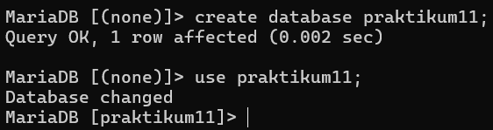

2. Membuat Table
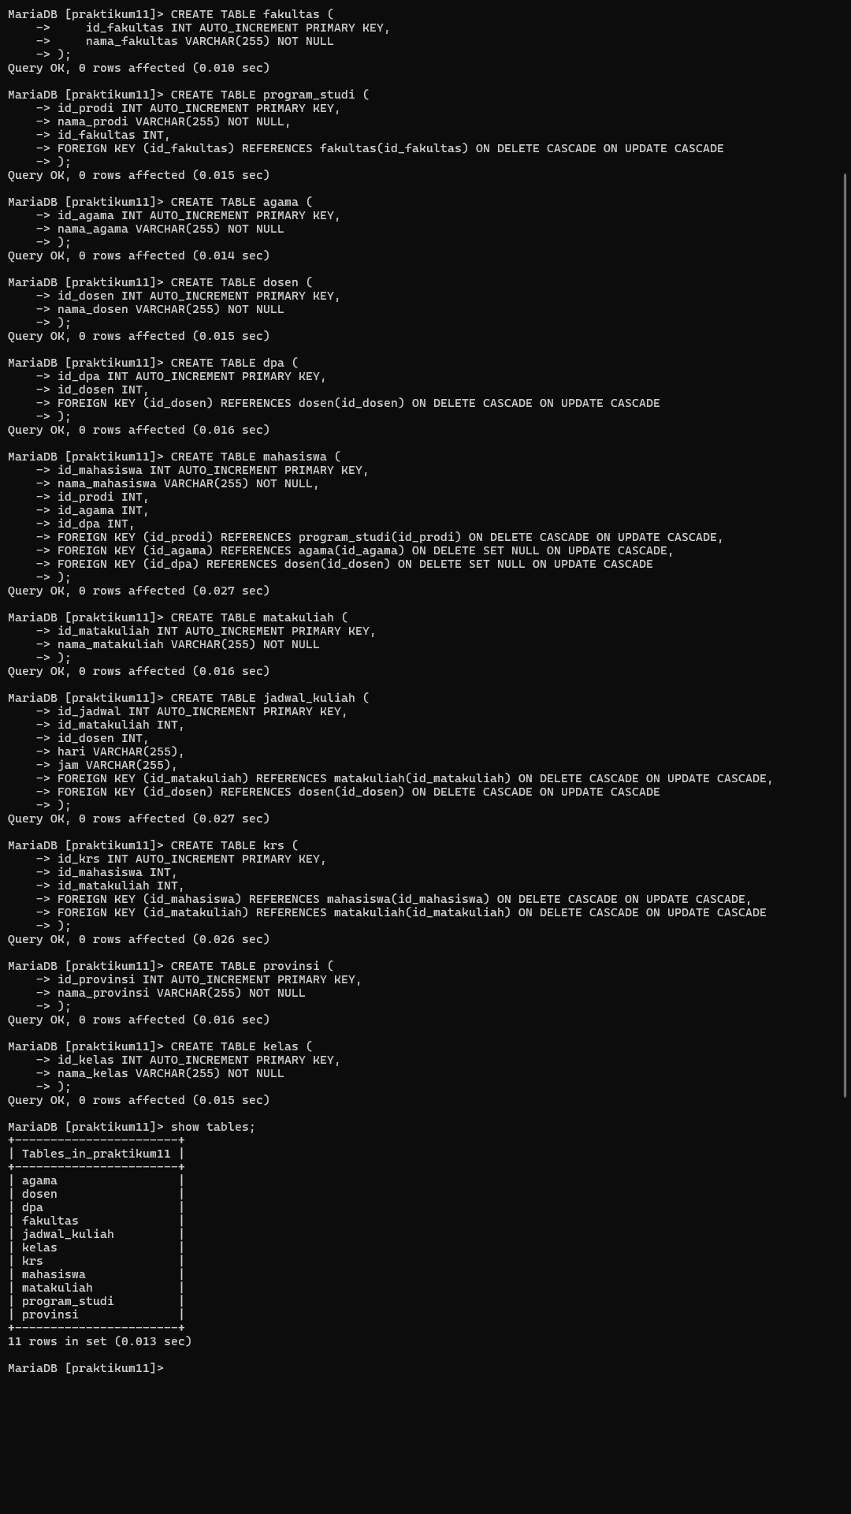
3. Relassi Database praktikum11
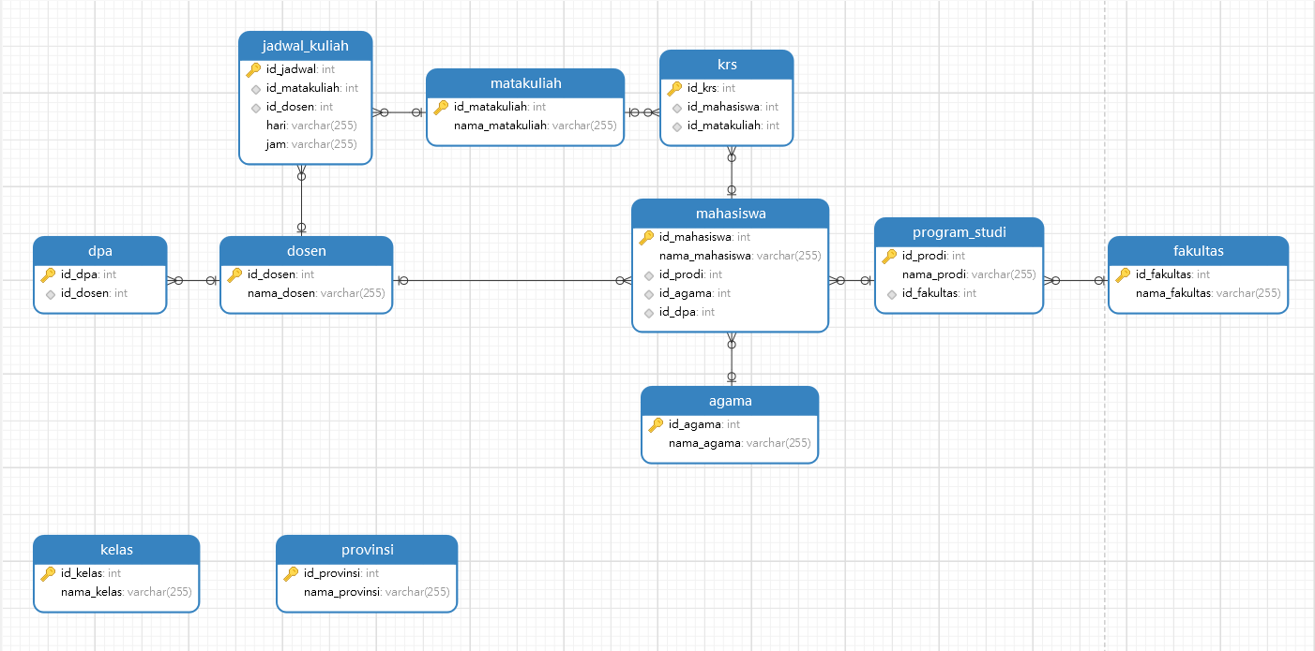

4. Membuat 3 Sample data di dalam masing-masing table
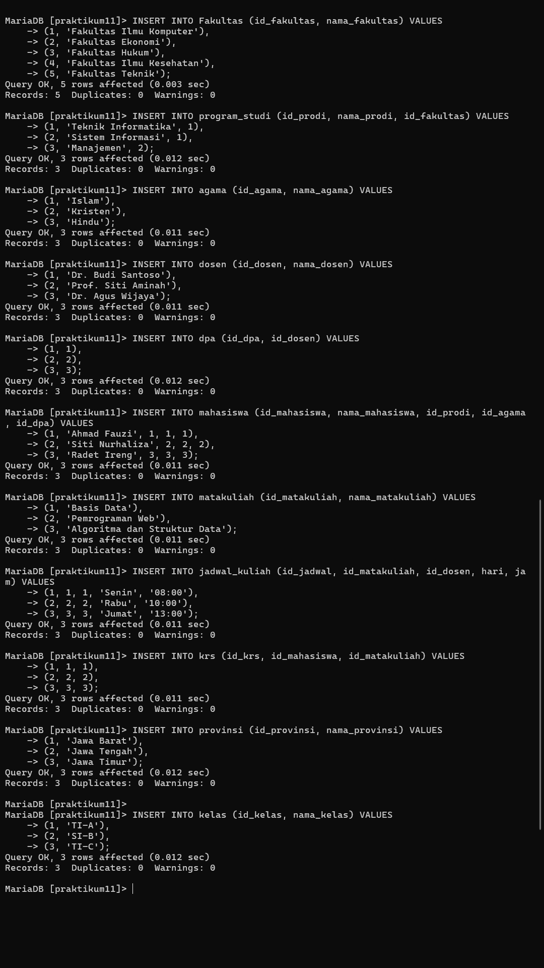

5. Perintah SQL Untuk Mahasiswa Melihat KRS
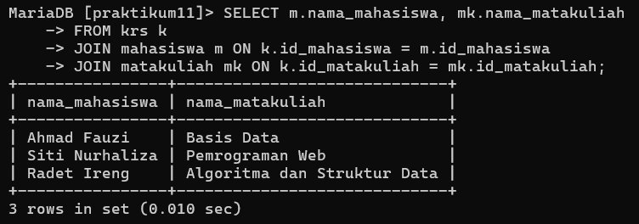

6. Perintah SQL Untuk Mahasiswa Melihat Jadwal
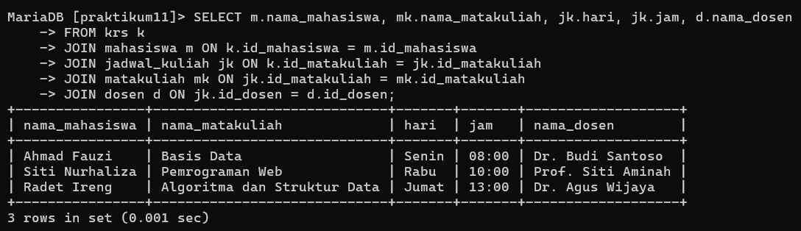

7. Perintah SQL Untuk Mahasiswa Melihat DPA nya
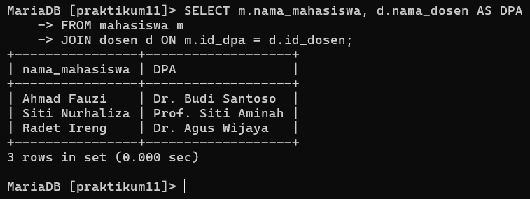

Microsoft Windows [Version 10.0.22631.4460]
(c) Microsoft Corporation. All rights reserved.

C:\Users\HP>cd/xampp/mysql/bin

C:\xampp\mysql\bin>mysql -u root
Welcome to the MariaDB monitor. Commands end with ; or \g.
Your MariaDB connection id is 8
Server version: 10.4.32-MariaDB mariadb.org binary distribution

Copyright (c) 2000, 2018, Oracle, MariaDB Corporation Ab and others.

Type 'help;' or '\h' for help. Type '\c' to clear the current input statement.

MariaDB [(none)]> create database praktikum11;
Query OK, 1 row affected (0.002 sec)

MariaDB [(none)]> use praktikum11;
Database changed
MariaDB [praktikum11]> CREATE TABLE fakultas (
-> id_fakultas INT AUTO_INCREMENT PRIMARY KEY,
-> nama_fakultas VARCHAR(255) NOT NULL
-> );
Query OK, 0 rows affected (0.010 sec)

MariaDB [praktikum11]> CREATE TABLE program_studi (
-> id_prodi INT AUTO_INCREMENT PRIMARY KEY,
-> nama_prodi VARCHAR(255) NOT NULL,
-> id_fakultas INT,
-> FOREIGN KEY (id_fakultas) REFERENCES fakultas(id_fakultas) ON DELETE CASCADE ON UPDATE CASCADE
-> );
Query OK, 0 rows affected (0.015 sec)

MariaDB [praktikum11]> CREATE TABLE agama (
-> id_agama INT AUTO_INCREMENT PRIMARY KEY,
-> nama_agama VARCHAR(255) NOT NULL
-> );
Query OK, 0 rows affected (0.014 sec)

MariaDB [praktikum11]> CREATE TABLE dosen (
-> id_dosen INT AUTO_INCREMENT PRIMARY KEY,
-> nama_dosen VARCHAR(255) NOT NULL
-> );
Query OK, 0 rows affected (0.015 sec)

MariaDB [praktikum11]> CREATE TABLE dpa (
-> id_dpa INT AUTO_INCREMENT PRIMARY KEY,
-> id_dosen INT,
-> FOREIGN KEY (id_dosen) REFERENCES dosen(id_dosen) ON DELETE CASCADE ON UPDATE CASCADE
-> );
Query OK, 0 rows affected (0.016 sec)

MariaDB [praktikum11]> CREATE TABLE mahasiswa (
-> id_mahasiswa INT AUTO_INCREMENT PRIMARY KEY,
-> nama_mahasiswa VARCHAR(255) NOT NULL,
-> id_prodi INT,
-> id_agama INT,
-> id_dpa INT,
-> FOREIGN KEY (id_prodi) REFERENCES program_studi(id_prodi) ON DELETE CASCADE ON UPDATE CASCADE,
-> FOREIGN KEY (id_agama) REFERENCES agama(id_agama) ON DELETE SET NULL ON UPDATE CASCADE,
-> FOREIGN KEY (id_dpa) REFERENCES dosen(id_dosen) ON DELETE SET NULL ON UPDATE CASCADE
-> );
Query OK, 0 rows affected (0.027 sec)

MariaDB [praktikum11]> CREATE TABLE matakuliah (
-> id_matakuliah INT AUTO_INCREMENT PRIMARY KEY,
-> nama_matakuliah VARCHAR(255) NOT NULL
-> );
Query OK, 0 rows affected (0.016 sec)

MariaDB [praktikum11]> CREATE TABLE jadwal_kuliah (
-> id_jadwal INT AUTO_INCREMENT PRIMARY KEY,
-> id_matakuliah INT,
-> id_dosen INT,
-> hari VARCHAR(255),
-> jam VARCHAR(255),
-> FOREIGN KEY (id_matakuliah) REFERENCES matakuliah(id_matakuliah) ON DELETE CASCADE ON UPDATE CASCADE,
-> FOREIGN KEY (id_dosen) REFERENCES dosen(id_dosen) ON DELETE CASCADE ON UPDATE CASCADE
-> );
Query OK, 0 rows affected (0.027 sec)

MariaDB [praktikum11]> CREATE TABLE krs (
-> id_krs INT AUTO_INCREMENT PRIMARY KEY,
-> id_mahasiswa INT,
-> id_matakuliah INT,
-> FOREIGN KEY (id_mahasiswa) REFERENCES mahasiswa(id_mahasiswa) ON DELETE CASCADE ON UPDATE CASCADE,
-> FOREIGN KEY (id_matakuliah) REFERENCES matakuliah(id_matakuliah) ON DELETE CASCADE ON UPDATE CASCADE
-> );
Query OK, 0 rows affected (0.026 sec)

MariaDB [praktikum11]> CREATE TABLE provinsi (
-> id_provinsi INT AUTO_INCREMENT PRIMARY KEY,
-> nama_provinsi VARCHAR(255) NOT NULL
-> );
Query OK, 0 rows affected (0.016 sec)

MariaDB [praktikum11]> CREATE TABLE kelas (
-> id_kelas INT AUTO_INCREMENT PRIMARY KEY,
-> nama_kelas VARCHAR(255) NOT NULL
-> );
Query OK, 0 rows affected (0.015 sec)

MariaDB [praktikum11]> show tables;
+-----------------------+
| Tables_in_praktikum11 |
+-----------------------+
| agama |
| dosen |
| dpa |
| fakultas |
| jadwal_kuliah |
| kelas |
| krs |
| mahasiswa |
| matakuliah |
| program_studi |
| provinsi |
+-----------------------+
11 rows in set (0.013 sec)

MariaDB [praktikum11]> INSERT INTO Fakultas (id_fakultas, nama_fakultas) VALUES
-> (1, 'Fakultas Ilmu Komputer'),
-> (2, 'Fakultas Ekonomi'),
-> (3, 'Fakultas Hukum'),
-> (4, 'Fakultas Ilmu Kesehatan'),
-> (5, 'Fakultas Teknik');
Query OK, 5 rows affected (0.003 sec)
Records: 5 Duplicates: 0 Warnings: 0

MariaDB [praktikum11]> INSERT INTO program_studi (id_prodi, nama_prodi, id_fakultas) VALUES
-> (1, 'Teknik Informatika', 1),
-> (2, 'Sistem Informasi', 1),
-> (3, 'Manajemen', 2);
Query OK, 3 rows affected (0.012 sec)
Records: 3 Duplicates: 0 Warnings: 0

MariaDB [praktikum11]> INSERT INTO agama (id_agama, nama_agama) VALUES
-> (1, 'Islam'),
-> (2, 'Kristen'),
-> (3, 'Hindu');
Query OK, 3 rows affected (0.011 sec)
Records: 3 Duplicates: 0 Warnings: 0

MariaDB [praktikum11]> INSERT INTO dosen (id_dosen, nama_dosen) VALUES
-> (1, 'Dr. Budi Santoso'),
-> (2, 'Prof. Siti Aminah'),
-> (3, 'Dr. Agus Wijaya');
Query OK, 3 rows affected (0.011 sec)
Records: 3 Duplicates: 0 Warnings: 0
MariaDB [praktikum11]> INSERT INTO dpa (id_dpa, id_dosen) VALUES
-> (1, 1),
-> (2, 2),
-> (3, 3);
Query OK, 3 rows affected (0.012 sec)
Records: 3 Duplicates: 0 Warnings: 0

MariaDB [praktikum11]> INSERT INTO mahasiswa (id_mahasiswa, nama_mahasiswa, id_prodi, id_agama, id_dpa) VALUES
-> (1, 'Ahmad Fauzi', 1, 1, 1),
-> (2, 'Siti Nurhaliza', 2, 2, 2),
-> (3, 'Radet Ireng', 3, 3, 3);
Query OK, 3 rows affected (0.011 sec)
Records: 3 Duplicates: 0 Warnings: 0

MariaDB [praktikum11]> INSERT INTO matakuliah (id_matakuliah, nama_matakuliah) VALUES
-> (1, 'Basis Data'),
-> (2, 'Pemrograman Web'),
-> (3, 'Algoritma dan Struktur Data');
Query OK, 3 rows affected (0.011 sec)
Records: 3 Duplicates: 0 Warnings: 0

MariaDB [praktikum11]> INSERT INTO jadwal_kuliah (id_jadwal, id_matakuliah, id_dosen, hari, jam) VALUES
-> (1, 1, 1, 'Senin', '08:00'),
-> (2, 2, 2, 'Rabu', '10:00'),
-> (3, 3, 3, 'Jumat', '13:00');
Query OK, 3 rows affected (0.011 sec)
Records: 3 Duplicates: 0 Warnings: 0

MariaDB [praktikum11]> INSERT INTO krs (id_krs, id_mahasiswa, id_matakuliah) VALUES
-> (1, 1, 1),
-> (2, 2, 2),
-> (3, 3, 3);
Query OK, 3 rows affected (0.011 sec)
Records: 3 Duplicates: 0 Warnings: 0

MariaDB [praktikum11]> INSERT INTO provinsi (id_provinsi, nama_provinsi) VALUES
-> (1, 'Jawa Barat'),
-> (2, 'Jawa Tengah'),
-> (3, 'Jawa Timur');
Query OK, 3 rows affected (0.012 sec)
Records: 3 Duplicates: 0 Warnings: 0

MariaDB [praktikum11]>
MariaDB [praktikum11]> INSERT INTO kelas (id_kelas, nama_kelas) VALUES
-> (1, 'TI-A'),
-> (2, 'SI-B'),
-> (3, 'TI-C');
Query OK, 3 rows affected (0.012 sec)
Records: 3 Duplicates: 0 Warnings: 0

MariaDB [praktikum11]> SELECT m.nama_mahasiswa, mk.nama_matakuliah
-> FROM krs k
-> JOIN mahasiswa m ON k.id_mahasiswa = m.id_mahasiswa
-> JOIN matakuliah mk ON k.id_matakuliah = mk.id_matakuliah;
+----------------+-----------------------------+
| nama_mahasiswa | nama_matakuliah |
+----------------+-----------------------------+
| Ahmad Fauzi | Basis Data |
| Siti Nurhaliza | Pemrograman Web |
| Radet Ireng | Algoritma dan Struktur Data |
+----------------+-----------------------------+
3 rows in set (0.010 sec)

MariaDB [praktikum11]> SELECT m.nama_mahasiswa, mk.nama_matakuliah, jk.hari, jk.jam, d.nama_dosen
-> FROM krs k
-> JOIN mahasiswa m ON k.id_mahasiswa = m.id_mahasiswa
-> JOIN jadwal_kuliah jk ON k.id_matakuliah = jk.id_matakuliah
-> JOIN matakuliah mk ON jk.id_matakuliah = mk.id_matakuliah
-> JOIN dosen d ON jk.id_dosen = d.id_dosen;

+----------------+-----------------------------+-------+-------+-------------------+
| nama_mahasiswa | nama_matakuliah | hari | jam | nama_dosen |
+----------------+-----------------------------+-------+-------+-------------------+
| Ahmad Fauzi | Basis Data | Senin | 08:00 | Dr. Budi Santoso |
| Siti Nurhaliza | Pemrograman Web | Rabu | 10:00 | Prof. Siti Aminah |
| Radet Ireng | Algoritma dan Struktur Data | Jumat | 13:00 | Dr. Agus Wijaya |
+----------------+-----------------------------+-------+-------+-------------------+
3 rows in set (0.001 sec)

MariaDB [praktikum11]> SELECT m.nama_mahasiswa, d.nama_dosen AS DPA
-> FROM mahasiswa m
-> JOIN dosen d ON m.id_dpa = d.id_dosen;
+----------------+-------------------+
| nama_mahasiswa | DPA |
+----------------+-------------------+
| Ahmad Fauzi | Dr. Budi Santoso |
| Siti Nurhaliza | Prof. Siti Aminah |
| Radet Ireng | Dr. Agus Wijaya |
+----------------+-------------------+
3 rows in set (0.000 sec)

MariaDB [praktikum11]>

